COLLABORATION WITH INSTITUTE GEOLOGICAL OF SCIENCES, POLISH ACADEMY OF SCIENCES
(IGS-PAS), 2022
- VISITING PROFESSOR ONLINE: LECTURE FOR IGS PAS

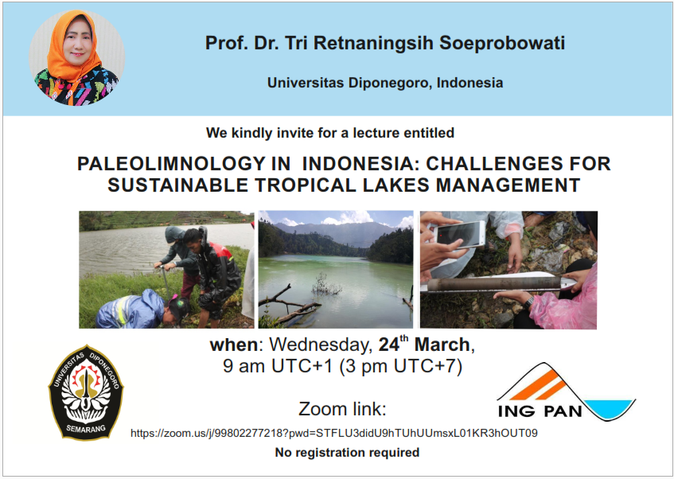

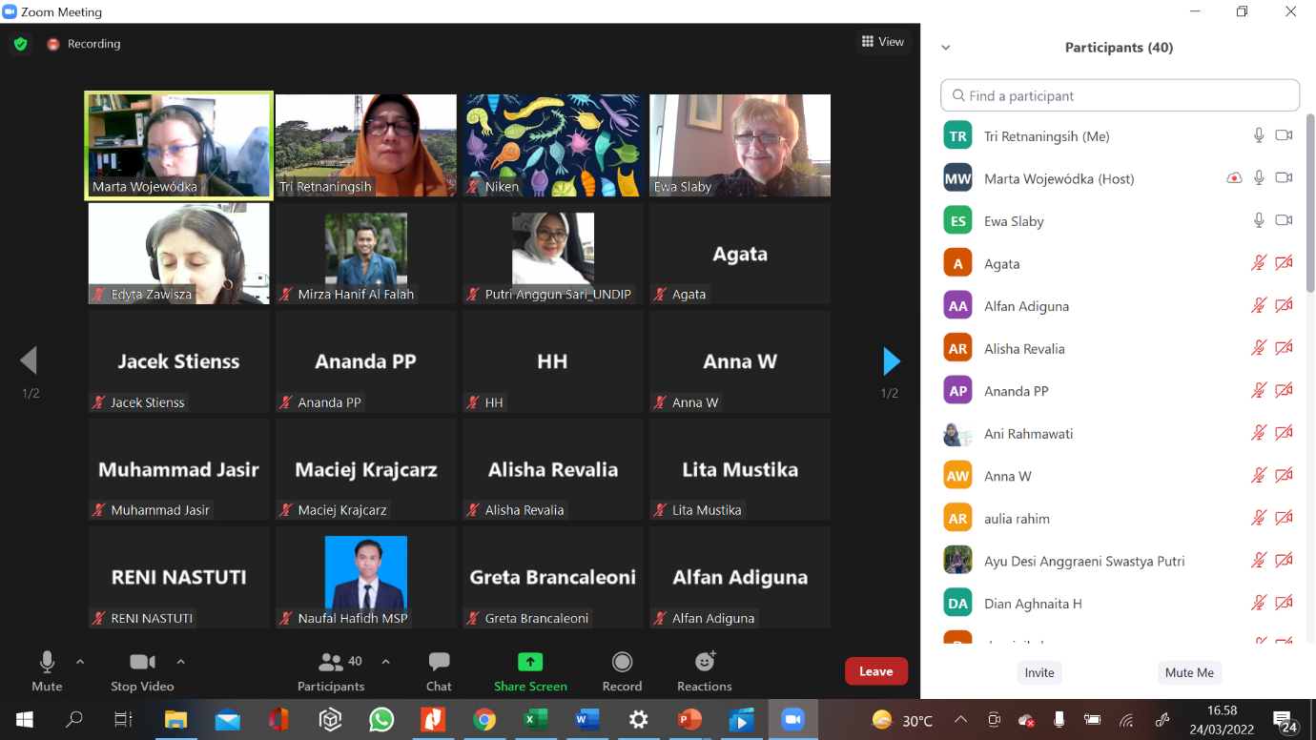

- Research collaboration between SPS UNDIP -IGS PAS-BRIN-UI-UNAND
https://m.facebook.com/story.php?story_fbid=pfbid07DhjpFkuULmFbq1Chn7C8Wu9G2WSh1f8GooAMcQSRvhbnwuiaKG9JSKK1mqQtJVVl&id=100064276976334&mibextid=Nif5oz

- JOIN PUBLICATION AS OUTPUT OF RESEARCH COLLABORATION:
Published Q1: Sediment organic carbon stocks in tropical lake and its implication for sustainable lake management ( https://doi.org/10.22034/gjesm.2023.02.01)

